3.9 JavaScript: Webpack and Modern JavaScript

This section will guide you to:

* Create a JavaScript project in your IDE
* Write a program in JavaScript to implement webpack and modern JavaScript

This lab has three subsections, namely:

* + 1. Writing a program in JavaScript to verify implementation of webpack and modern JavaScript
    2. Executing the program and verifying implementation of webpack and modern JavaScript
    3. Pushing the code to your GitHub repositories

**Step 3.9.1:** Writing a program in JavaScript to verify implementation of webpack and modern JavaScript

* Install yarn using the following command:

*npm i yarn –g*

* Create a new directory and move into the folder:

*mkdir webpack*

*cd webpack*

* Initialize a package.json by running the following command:

*npm init –y*

Pull webpack 4 in it.

yarn add --dev webpack webpack-dev-server

We need webpack-cli also, which lives as a separate package.

*yarn add webpack webpack-cli --dev*

* Open package.json and add the following build script:

*“scripts”: {*

*“build”: “webpack”*

*}*

{

*"name"*: "webpack",

*"version"*: "1.0.0",

*"description"*: "",

*"main"*: "index.js",

*"scripts"*: {

*"build"*: "webpack",

*"test"*: "echo \"Error: no test specified\" && exit 1"

  },

*"keywords"*: [],

*"author"*: "",

*"license"*: "ISC",

*"devDependencies"*: {

*"webpack"*: "^5.76.2",

*"webpack-cli"*: "^5.0.1",

*"webpack-dev-server"*: "^4.12.0"

  }

}

Close the file and save it.

* Webpack 4 will need an entry point to start building the JavaScript bundle. It will take ./src/index.js as the default entry point.
* Create a folder named *src.* Create a JavaScript file inside the *src* folder named operation.js. Add the following code in it

*module*.*exports* = {

    sum: *function*(*a*,*b*) {

    return *a*+*b*

    },

    sub: *function*(*a*,*b*) {

        return *a*-*b*

    },

    mul: *function*(*a*,*b*) {

            return *a*\**b*

    },

    div: *function*(*a*,*b*) {

             return *a*\**b*

    }

};

* Create another JavaScript file named *index.js* and add the following code in it:

*var* obj = require("./operation.js");

*var* sumResult = obj.sum(10,20);

*var* subResult = obj.sub(20,10);

*var* mulResult = obj.mul(5,2);

*var* divResult = obj.div(20,2);

console.log("sum: "+sumResult);

console.log("sub: "+subResult);

console.log("mul: "+mulResult);

console.log("div: "+divResult);

**Step 3.9.2:** Executing the program and verifying the implementation of webpack and modern JavaScript

Before you execute the program, check for syntactical corrections. If no errors are found, follow the steps mentioned below:

* Run the build using the following command:

*npm run build*

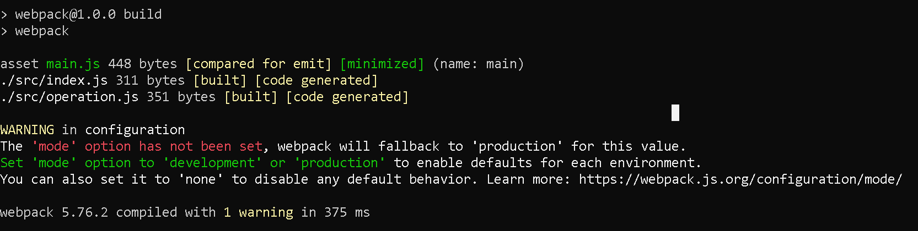

You will the get the bundle in *~/webpack/dist/main.js*.

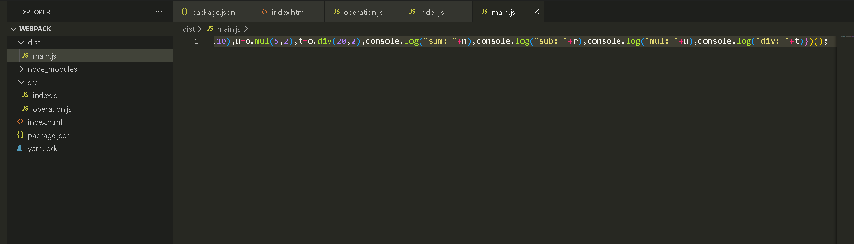

* Run the following command:

*node index.js*

**Output:**

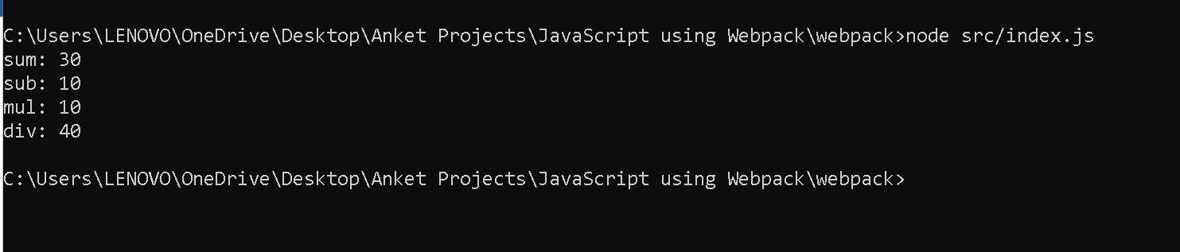

You can view the output using index.html page

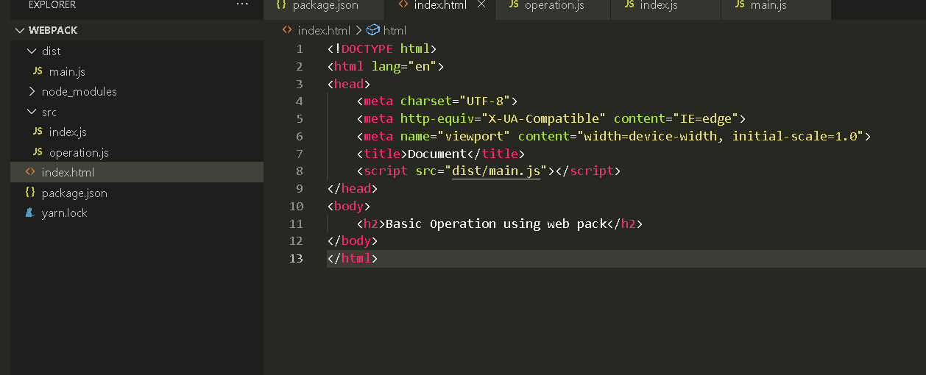

Now run the index.html page

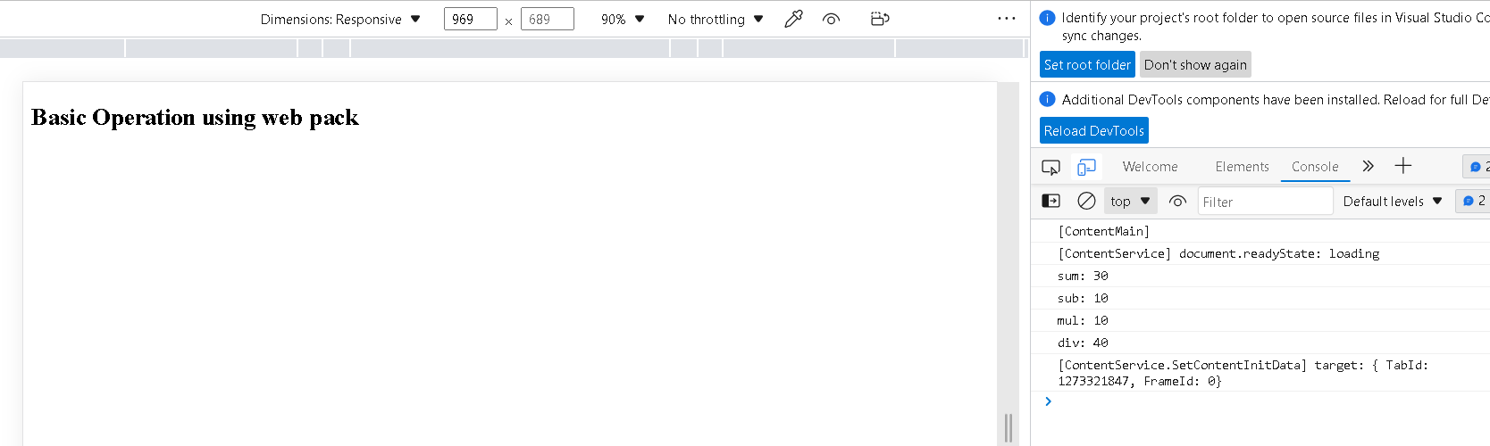

**Step 3.9.3:** Pushing the code to your GitHub repositories

Open your command prompt and navigate to the folder where you have created your files.

cd <folder path>

Initialize your repository using the following command:

git init

Add all the files to your git repository using the following command:

git add .

Commit the changes using the following command:

git commit . -m “Changes have been committed.”

Push the files to the folder you initially created using the following command:

git push -u origin master